1. - get excels from universities (TEAM WP2: this excel sent by e-mail )

Copy to Microsoft Teams -> DN-APP-Unita->Files->General->WP2->DEMO FILES NEW TEMPLATE

exemple: 1 - UNITO Templates Format Proposal Subjects and Degrees.xls

this excel contains two sheets:

- Template for SUBJECTS' Matrix

- Template for DEGREES' Matrix

2. - convert excels to csv (one csv by sheet) COPY to Microsoft Teams -> DN-APP-Unita->Files->General->WP2->DEMO FILES NEW TEMPLATE -> CSV

generated manually with excel (no first line title included/only data)

example of result:

- 1 - UNITO Templates Format Proposal Subjects and Degrees.xlsx - Template for DEGREES' Matrix.csv

- 1 - UNITO Templates Format Proposal Subjects and Degrees.xlsx - Template for SUBJECTS' Matrix.csv

3. - POSTGRES :

- create database "demo"

- create schema import

4. - EXECUTE script : <https://gricad-gitlab.univ-grenoble-alpes.fr/camachro/unitacarto/-/blob/main/Data/v1.0/create_import.sql>

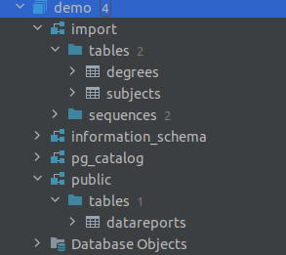

5. - IMPORT DEGREES from all files : * Templates Format Proposal Subjects and Degrees.xlsx - Template for DEGREES' Matrix.csv

From datagrip : right click on Degrees - > Import Data From File …

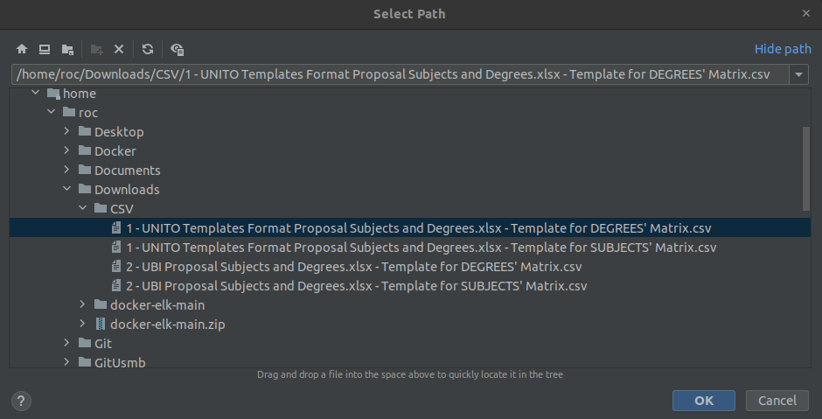

Change degree_university_short_name Default to ‘NAMEUNIVERSITY’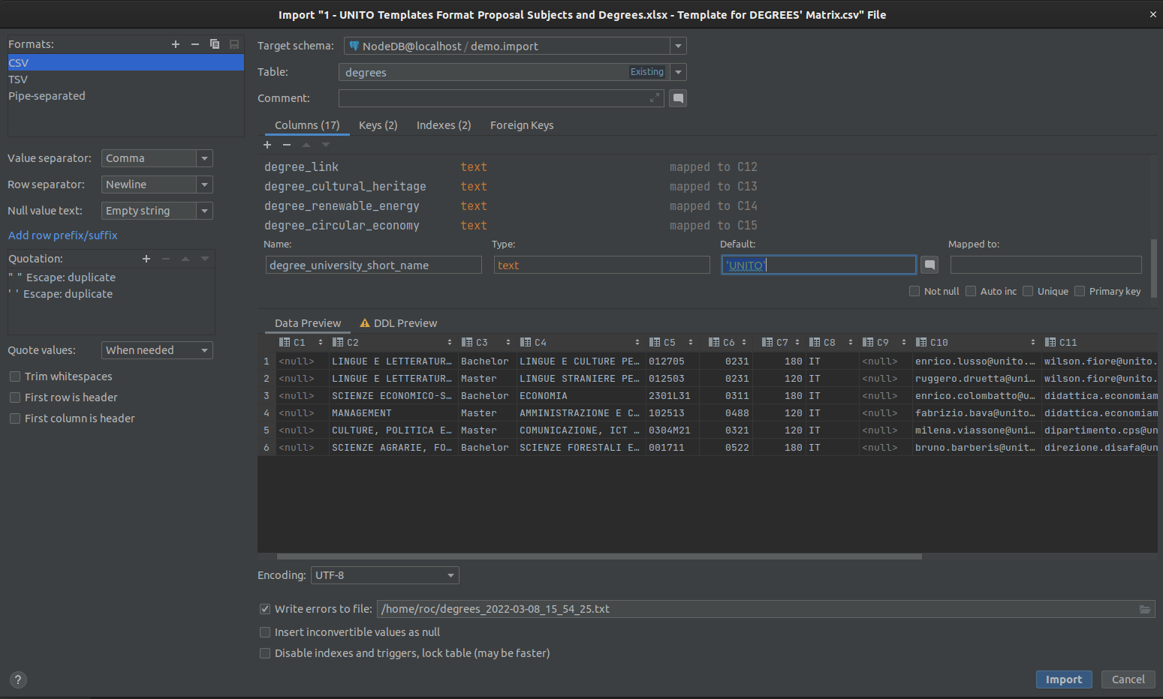

5. - IMPORT SUBJECTS from all files : * Templates Format Proposal Subjects and Degrees.xlsx - Template for SUBJECTS' Matrix.csv

From datagrip : right click on Subjects - > Import Data From File …

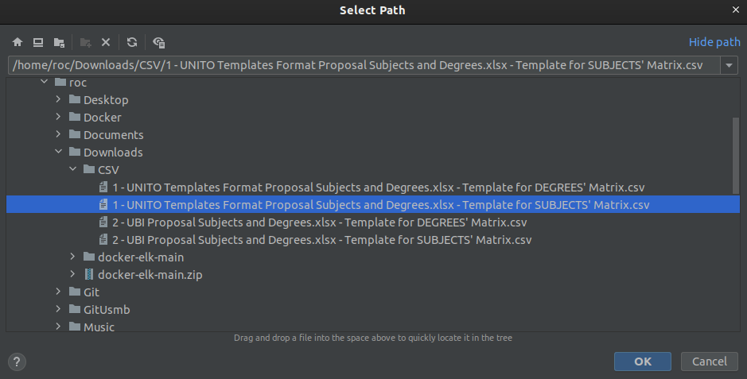

Change subject_university_short_name Default to ‘NAMEUNIVERSITY’

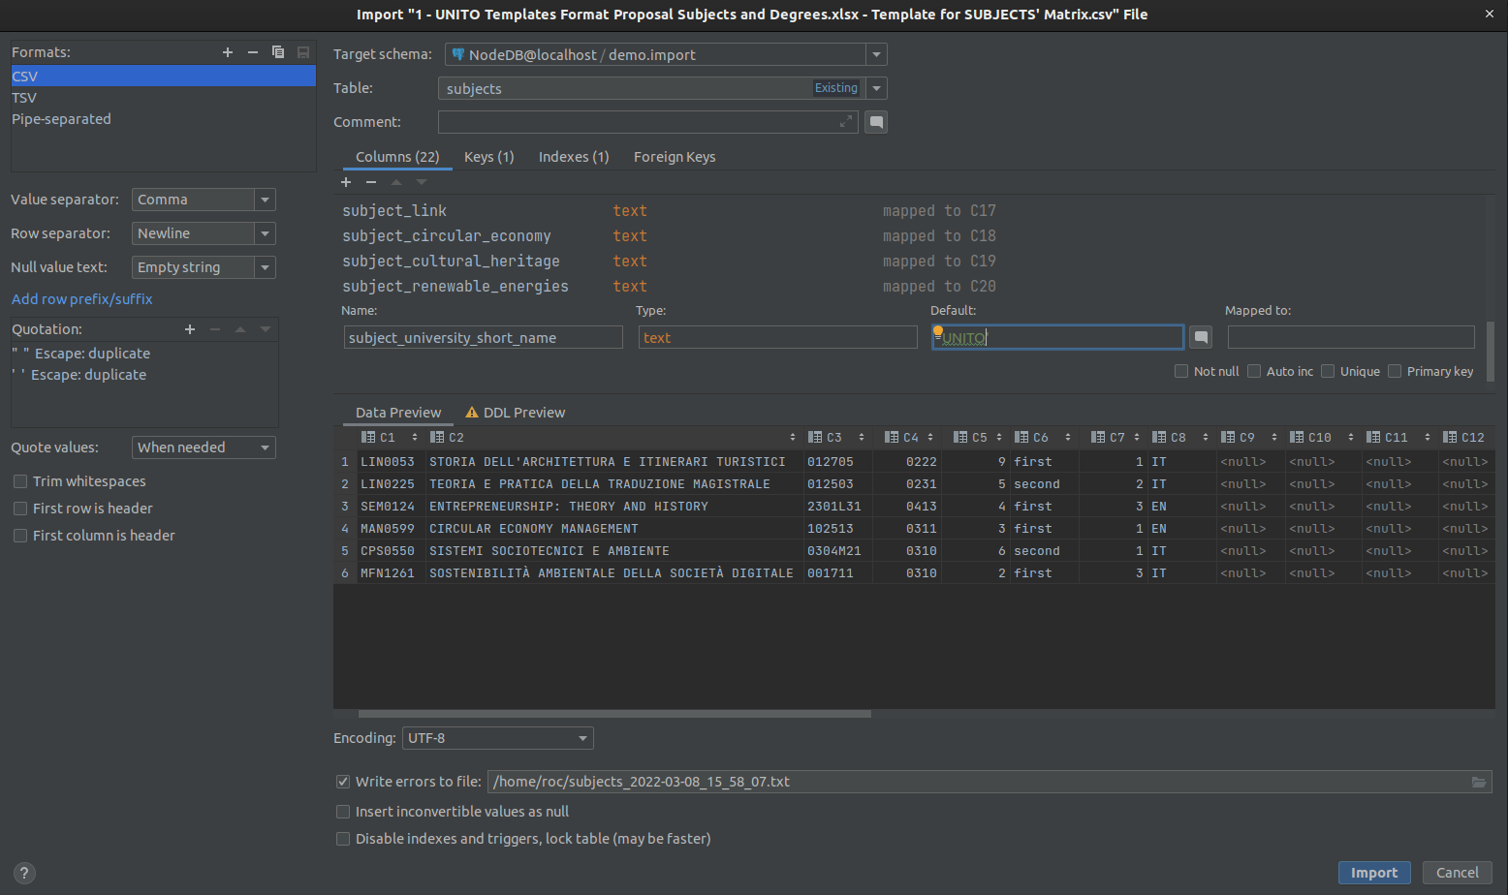

6. - Execute select : <https://gricad-gitlab.univ-grenoble-alpes.fr/camachro/unitacarto/-/blob/main/Data/v1.0/get_data_from_import.sql>

And export result in csv  (click download)

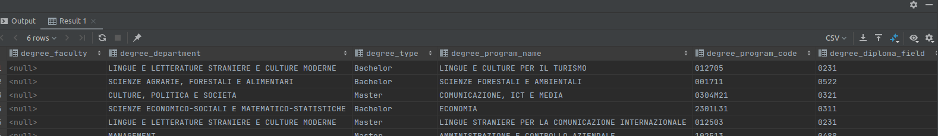

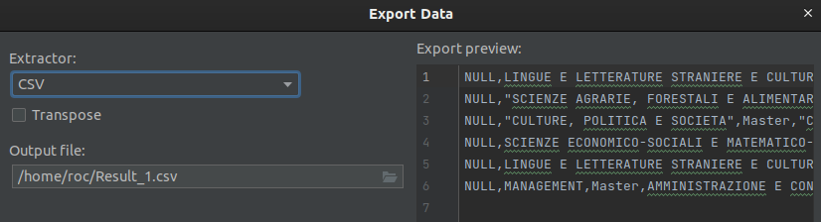

7. - Import Result_1.csv into public datareports.

8. - Download elastic search :

<https://github.com/deviantony/docker-elk>

Click -> Code -> Download ZIP

9. - Unzip and copy to Home\Docker

10. - Open file Home\Docker\docker-elk-main\elasticsearch\config\elasticsearch.yml

Set:

xpack.security.enabled: false

(x-pack for 30 days. You can later downgrade the cluster to a basic license if needed.)

11. - In Terminal

roc@hal:~$ **cd Docker/docker-elk-main**

roc@hal:~/Docker/docker-elk-main$ **docker-compose up -d --build**

If all is right: <http://localhost:9200/> you will have elastic running

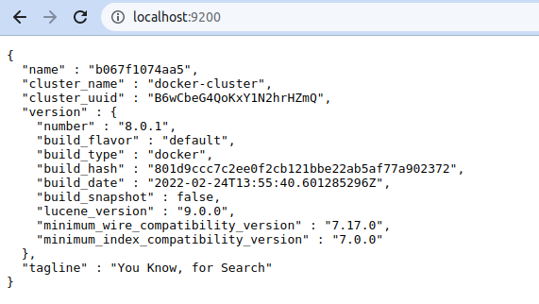

12. - Execute script: <https://gricad-gitlab.univ-grenoble-alpes.fr/camachro/unitacarto/-/blob/main/Data/v1.0/count_data.sql>

13. - Execute script: <https://gricad-gitlab.univ-grenoble-alpes.fr/camachro/unitacarto/-/blob/main/Data/v1.0/get_data.sql>

14. - download code of vsc: <https://gricad-gitlab.univ-grenoble-alpes.fr/camachro/unitacarto/-/tree/main/jsonTOndjson>

15. - Open in vsc and In the terminal of VSC execute: python main.py

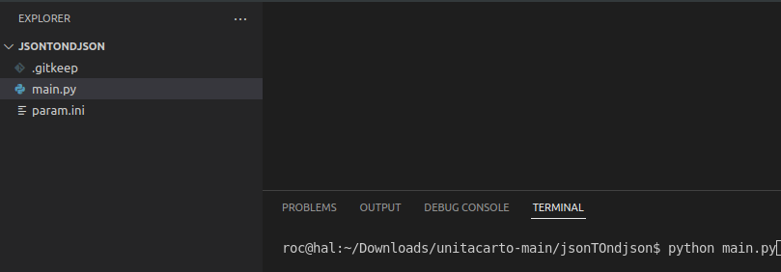

(Maybe libraries needed vsc : python and pip3 check if needed :pyscopg2 (pip3 install psycopg2-binary)

Result will be like:

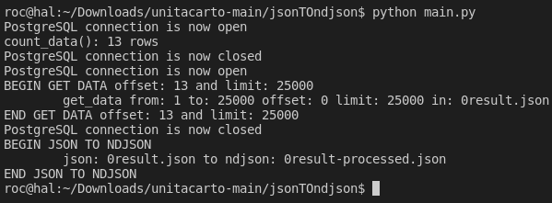

And created 2 files: (maybe more if more than 25000 rows)



0result.json: json from database

0result-processed.json json needed for elasticsearch

16. - Go to kibana: <http://localhost:5601/>

Go to Menu-> Machine Learning

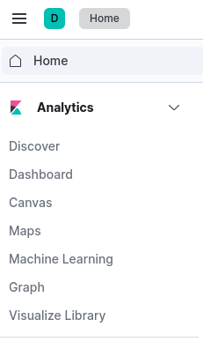

Click on Data Visualizer

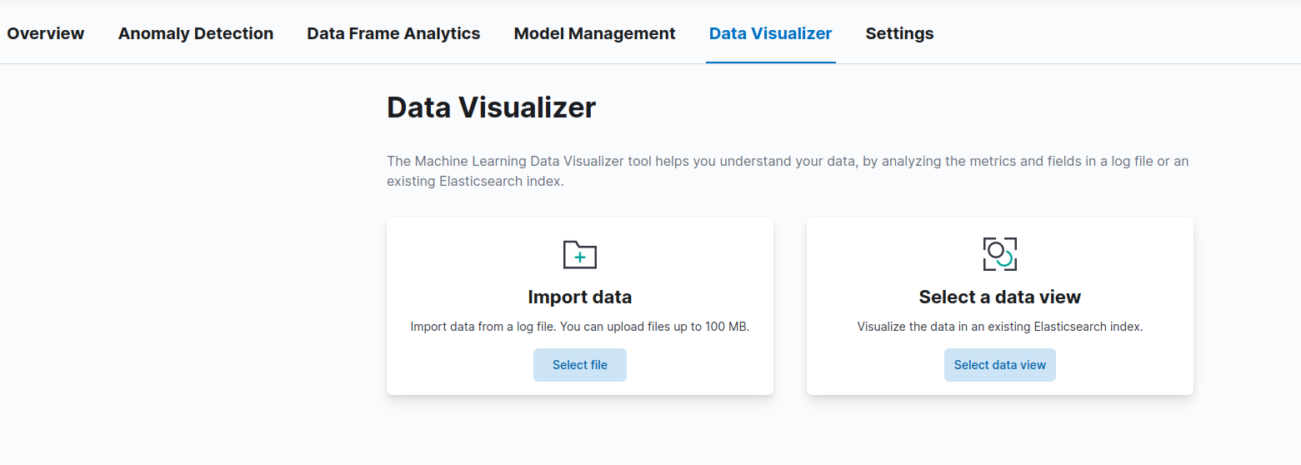

Click on Import data-> select file

